Practical 9
Cross-platform communication

Steps: -
- In Command Prompt: pip install fastapi uvicorn.
- Open Microsoft Visual Studio 2019.
- Create a new project – Console App (.NET Core)/ Just Console App
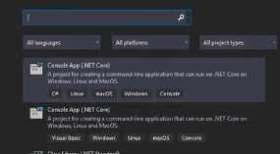
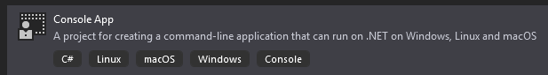
- Now Open Python IDE and create a file and write the below code:
from fastapi import FastAPI
app = FastAPI()

@app.get("/hello")

def hello(name: str = "World"):
return {"message": f"Hello {name} from Python API!"}

- To run the file go to the CMD and direct to the python file location and
python -m uvicorn practical9:app --reload --port 8000
here the practical9 is the python file name.
- In the Microsoft Visual Studio 2019 – In the project open Program.cs and write the below code and run while keeping the localhost on in the cmd:
using System;
using System.Net.Http;
using System.Threading.Tasks;

class Program
{
static async Task Main()
{
using var client = new HttpClient();

var response = await client.GetAsync("http://localhost:8000/hello?name=ASH");

var content = await response.Content.ReadAsStringAsync();

Console.WriteLine("Response from Python API:");
Console.WriteLine(content);
}
}

Output: -
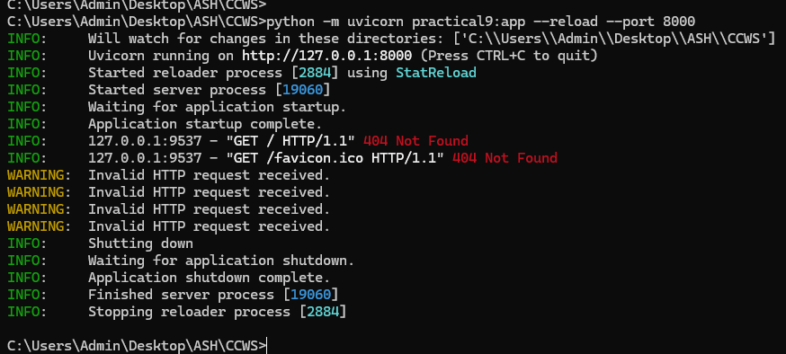
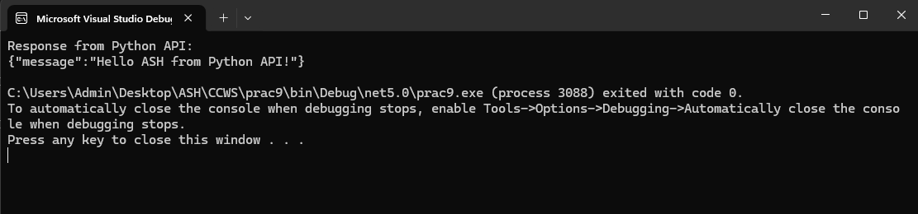
http://localhost:8000/hello?name=ASH
